**Table 1: Population characteristics of European ancestry samples extracted from UKB.**

|  |  |
| --- | --- |
| **Table 1a. Population characteristics** (n=378,051) | |
| **AGE** | 56.73 + 8.02 |
| **SEX (MALE)** | 46% |
| **T2D** | 4% |
| **BMI** | 27.37 + 4.76 |
| **MDI** | 16.88 + 13.5 |
| **MDI 25th** | 26% |

|  |  |  |
| --- | --- | --- |
| **Table 1b. Population characteristics stratified by case** (n=378,051) | | |
|  | Control  (n= 375,649) | Case  (n= 2,402) |
| **AGE** | 56.7 (8) | 57.9 (8.6) |
| **SEX** | 46% | 54% |
| **BMI** | 27.4 (4.8) | 29.3 (5.4) |
| **T2D** | 4% | 10% |
| **MDI** | 16.8 (13.5) | 22.1 (16.5) |

**Supp. Table 1: Population characteristics of European ancestry samples extracted from UKB, stratified by sex.**

|  |  |  |
| --- | --- | --- |
| **Supp. Table 1. Population characteristics stratified by sex** (n=378,051) | | |
| **Sex** | Female  (n= 203961) | Male  (n= 174090) |
| **Age** | 56.5 (7.9) | 57 (8.1) |
| **BMI** | 27 (5.1) | 27.8 (4.2) |
| **T2D** | 3% | 6% |
| **MDI** | 16.6 (13.2) | 17.2 (13.8) |

**Supp. Table 2: Top sex associations for exposures from interaction, joint, and stratified tests.**

|  |  |  |  |  |  |  |  |
| --- | --- | --- | --- | --- | --- | --- | --- |
| **RSID** | **location** | **alleles** | **Eff_Allele_Freq** | **OR interaction** | **OR combined** | **OR in males** | **OR in females** |
| **rs11115199** | 12:82510665 | G/T | 0.0204524 |  |  |  |  |
| rs2268616 | 14:75419444 | A/G | 0.0179341 | 1.23 [0.868-1.75] | 1.64 [1.38-1.94] | 1.79 [1.43-2.24] | 1.45 [1.11-1.9] |
| 2:218260234_AC_A | 2:218260234 | AC/A | 0.0256242 | 1.74 [1.24-2.45] | 1.44 [1.22-1.69] | 1.8 [1.47-2.19] | 1.03 [0.779-1.35] |
| rs61757880 | 14:75419928 | C/T | 0.0159929 | NA | NA | NA | NA |
| rs182113773 | 7:20239837 | C/A | 0.0147687 | 0.98 [0.657-1.45] | 1.73 [1.42-2.1] | 1.71 [1.3-2.23] | 1.75 [1.31-2.34] |
| rs117993077 | 6:93824151 | G/T | 0.0117114 | 2.67 [1.55-4.57] | 1.47 [1.16-1.85] | 2.06 [1.57-2.7] | 0.78 [0.487-1.24] |
| rs138080150 | 2:218257972 | C/T | 0.024267 | NA | NA | NA | NA |
| rs55926550 | 4:68007466 | G/C | 0.0124709 | 0.59 [0.388-0.911] | 1.6 [1.3-1.98] | 1.22 [0.882-1.69] | 2.05 [1.55-2.7] |
| rs11232355 | 11:80540380 | A/G | 0.0692849 | 0.58 [0.463-0.725] | 1.09 [0.972-1.21] | 0.82 [0.694-0.972] | 1.42 [1.22-1.64] |
| rs117234438 | 15:52349607 | A/G | 0.0106815 | 1.93 [1.17-3.19] | 1.64 [1.3-2.06] | 2.09 [1.59-2.76] | 1.08 [0.71-1.64] |
| rs796925608 | 13:68788267 | A/ACTTTGAAAATAAC | 0.897712 | 1.02 [0.827-1.26] | 0.76 [0.681-0.839] | 0.76 [0.662-0.879] | 0.75 [0.64-0.872] |
| rs112561874 | 1:185427460 | G/A | 0.0159888 | 0.47 [0.305-0.723] | 1.42 [1.15-1.74] | 0.94 [0.668-1.32] | 2 [1.53-2.6] |
| rs28756982 | 14:75515101 | C/T | 0.0158576 | NA | NA | NA | NA |
| rs12461506 | 19:30878810 | G/C | 0.643158 | 1.35 [1.19-1.52] | 1 [0.943-1.06] | 1.15 [1.06-1.25] | 0.85 [0.783-0.932] |
| rs11084549 | 19:30877813 | C/T | 0.643174 | NA | NA | NA | NA |
| rs2002997 | 19:30880662 | G/A | 0.643211 | NA | NA | NA | NA |

**Supp. Table 3: Top cardiometabolic (T2D and obesity) associations for exposures from interaction, joint, and stratified tests.**

|  |  |  |  |  |  |  |  |  |
| --- | --- | --- | --- | --- | --- | --- | --- | --- |
| **RSID** | **location** | **alleles** | **Eff_Allele_Freq** | **OR combined** | **OR in no_t2d** | **OR in T2D** | **OR in no_obesity** | **OR in obesity** |
| rs148793499 | 18:58314588 | T/C | 0.0102753 | 1.61 [1.27-2.03] | 1.56 [1.21-2.01] | 2.01 [1.03-3.93] | 1.18 [0.835-1.67] | 2.36 [1.7-3.27] |
| rs11115199 | 12:82510665 | G/T | 0.0204524 | 0.91 [0.736-1.12] | 0.72 [0.561-0.924] | 2.6 [1.73-3.91] | 0.96 [0.742-1.25] | 0.85 [0.592-1.22] |
| rs182113773 | 7:20239837 | C/A | 0.0147751 | 1.73 [1.42-2.1] | 1.62 [1.31-2.01] | 2.6 [1.57-4.3] | 1.63 [1.26-2.11] | 1.94 [1.43-2.64] |
| rs2268616 | 14:75419444 | A/G | 0.0179483 | 1.64 [1.38-1.94] | 1.6 [1.33-1.92] | 2.01 [1.22-3.32] | 1.82 [1.48-2.24] | 1.38 [1.01-1.88] |
| 12:82506024_GA_G | 12:82506024 | GA/G | 0.0205488 | NA | NA | NA | NA | NA |
| rs61757880 | 14:75419928 | C/T | 0.016006 | NA | NA | NA | NA | NA |
| rs6035512 | 20:19990781 | C/A | 0.0247661 | 1.41 [1.2-1.66] | 1.45 [1.22-1.72] | 1.15 [0.648-2.03] | 1.21 [0.97-1.52] | 1.74 [1.36-2.22] |
| rs141850011 | 13:61925813 | T/C | 0.0103374 | 1.17 [0.89-1.53] | 0.88 [0.639-1.22] | 3.67 [2.22-6.05] | 0.97 [0.669-1.41] | 1.53 [1.03-2.26] |
| rs192190941 | 13:61927395 | C/T | 0.0104139 | NA | NA | NA | NA | NA |
| rs2727176 | 15:100570438 | A/G | 0.0102964 | 1.21 [0.931-1.57] | 0.94 [0.686-1.28] | 3.79 [2.3-6.24] | 0.97 [0.669-1.4] | 1.56 [1.07-2.27] |
| rs150269257 | 18:58489340 | T/G | 0.0101581 | NA | NA | NA | NA | NA |
| rs72990790 | 18:58458978 | T/C | 0.010533 | NA | NA | NA | NA | NA |
| rs2727175 | 15:100570308 | T/G | 0.0103498 | NA | NA | NA | NA | NA |
| rs6747163 | 2:60777763 | C/G | 0.178678 | NA | NA | NA | NA | NA |
| rs5747202 | 22:17969179 | T/G | 0.0374612 | NA | NA | NA | NA | NA |

**Supp. Table 4: Top MDI associations for exposures from interaction, joint, and stratified tests.**

|  |  |  |  |  |  |  |  |
| --- | --- | --- | --- | --- | --- | --- | --- |
| **RSID** | **location** | **Eff_Allele_Freq** | **alleles** | **OR interaction** | **OR combined** | **OR low_sdh** | **OR high_sdh** |
| rs147319526 | 1:231731679 | 0.0124859 | A/G | 3.13 [1.41-6.91] | 0.98 [0.746-1.3] | 0.44 [0.212-0.893] | 1.35 [0.961-1.89] |
| rs76612061 | 15:49972935 | 0.0264085 | G/A | 1.95 [1.2-3.19] | 0.85 [0.697-1.03] | 0.56 [0.363-0.853] | 1.08 [0.848-1.37] |
| rs6966810 | 7:20141514 | 0.929889 | G/A | 0.88 [0.694-1.1] | 0.8 [0.724-0.889] | 0.84 [0.692-1.01] | 0.72 [0.632-0.827] |
| rs6948475 | 7:20141378 | 0.929668 | T/C | NA | NA | NA | NA |
| rs7797563 | 7:20129347 | 0.929218 | G/A | NA | NA | NA | NA |
| rs182113773 | 7:20239837 | 0.0147348 | C/A | 1.15 [0.735-1.81] | 1.73 [1.42-2.1] | 1.62 [1.12-2.34] | 1.87 [1.45-2.42] |
| rs10259063 | 7:20142634 | 0.929672 | C/T | NA | NA | NA | NA |
| rs200726807 | 7:20138471 | 0.929884 | AT/A | NA | NA | NA | NA |
| rs6959142 | 7:20128066 | 0.929843 | G/T | NA | NA | NA | NA |
| rs73164732 | 7:144481768 | 0.0115314 | G/A | 2.53 [1.26-5.09] | 1.17 [0.91-1.51] | 0.62 [0.332-1.17] | 1.6 [1.18-2.17] |
| rs2268616 | 14:75419444 | 0.0181362 | A/G | 0.8 [0.548-1.17] | 1.64 [1.38-1.94] | 1.89 [1.41-2.53] | 1.5 [1.17-1.92] |
| rs7779150 | 7:20128516 | 0.930094 | T/C | NA | NA | NA | NA |
| rs1156223 | 7:20126961 | 0.929424 | T/C | NA | NA | NA | NA |
| rs6969370 | 7:20130135 | 0.930363 | A/G | NA | NA | NA | NA |
| rs1646599 | 18:55236161 | 0.0117796 | G/A | 0.96 [0.841-1.1] | 1.05 [0.986-1.11] | 1.06 [0.948-1.17] | 1.02 [0.938-1.1] |

**Model**: log-odds(COVID Severity) = B_snp *SNP + B_MDI * MDI + B_snp_mdi * SNP * MDI

**Output**: 25th percentile; what is the value of the 25th percentile MDI in sample

**log-odds(COVID Severity)** = B_snp *SNP + B_MDI*[VALUE1] + B_snp_mdi*SNP * [VALUE1] → B_MDI*[VALUE1] + (B_snp + B_snp_mdi*VALUE1) *SNP

**Odds ratio** = exp(B_snp + B_snp_mdi*VALUE1) = X1

**var(beta_male)** = var(beta_Gmain) + var(beta_Interaction)**(sex0/1)^2 + 2**(sex0/1)*COV(beta_Gmain, beta_Interaction)

SE Odds Ratio = …

**Plot Templates**

**A. rs11115199 (12:82510665; MAF = 0.020)**

* Joint associations for T2D and obesity combine
* Odds ratio estimate ~0.76 from logistic regression on B2 case status (OR ~ 3.54 for cardiometabolic interactions (p value=1.5324-07))
* The eQTL relationships form GTEx show expression of METTL25 and DNA methylation of cg27158084, 5-methyluridine (ribothymidine)
* **In the T2D KP (knowledge portal) show associations with (-)Obesity (0.004) (+) T2D adjusted by BMI (p=0.03) (+) Weight (p=.049)**
* **Protective effect? Predispose to obesity but against T2D ?**

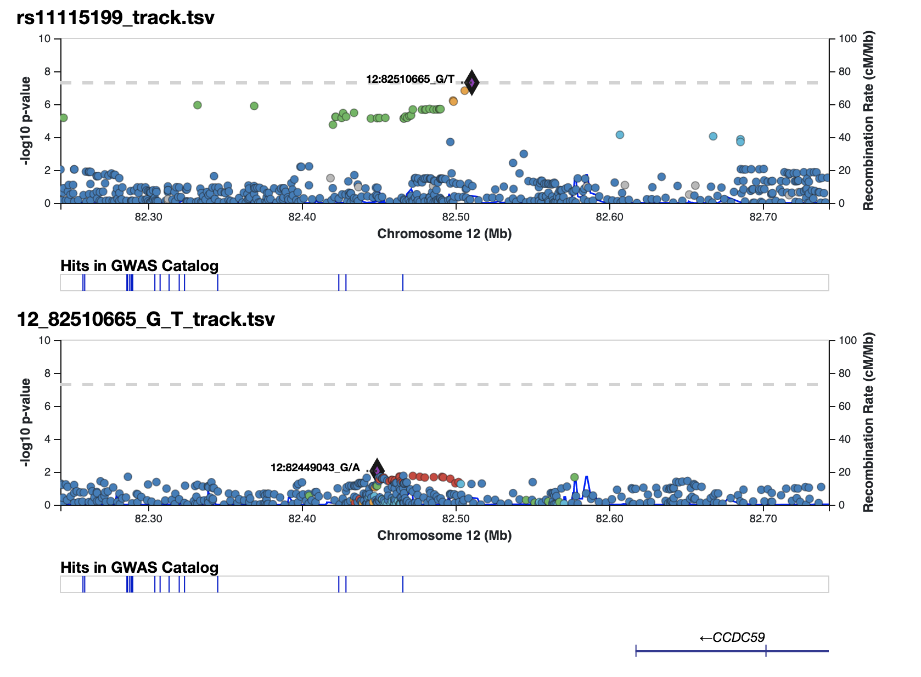

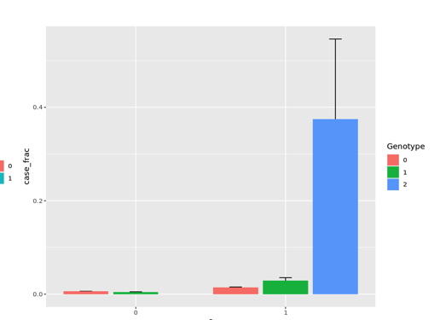

* **Small sample size, not sufficient to test in stratified genotype**

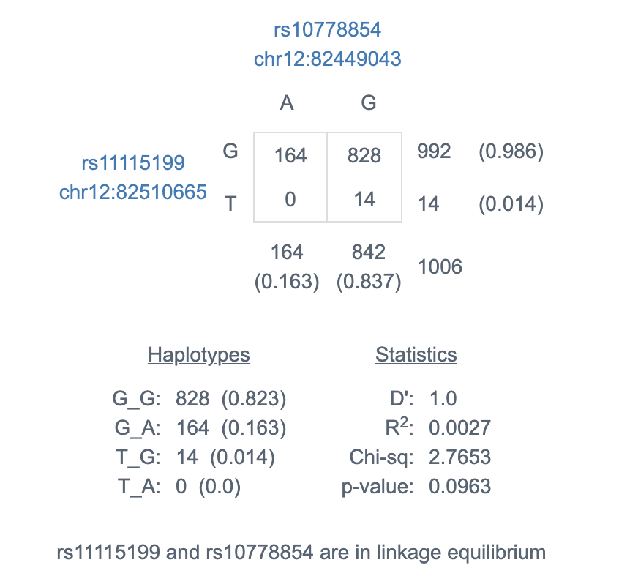

**B. Rs148793499 (18:58314588; MAF = 1%)**

* P ~ 1.8e-10 from cardiometabolic joint test
* Intergenic, no clear gene annotation nor molecular or GWAS trait associations
* Stratified genetic effects from logistic regression show more pronounced associations in T2D (somewhat) and obese (strongly)

|  |  |  |
| --- | --- | --- |
| Stratum | Odds ratio estimate | P-value |
| No T2D | 1.56 | 5.6e-4 |
| **T2D** | 2.01 | 0.039 |
| BMI < 30 | 1.18 | 0.34 |
| **BMI > 30** | 2.36 | 2.3e-7 |

* BMI > 30 bigger than BMI < 30, smaller p
* Clear interaction for BMI
* SNP works with obesity and non-specifically with T2D (smaller/sig pvalue but OR smaller)

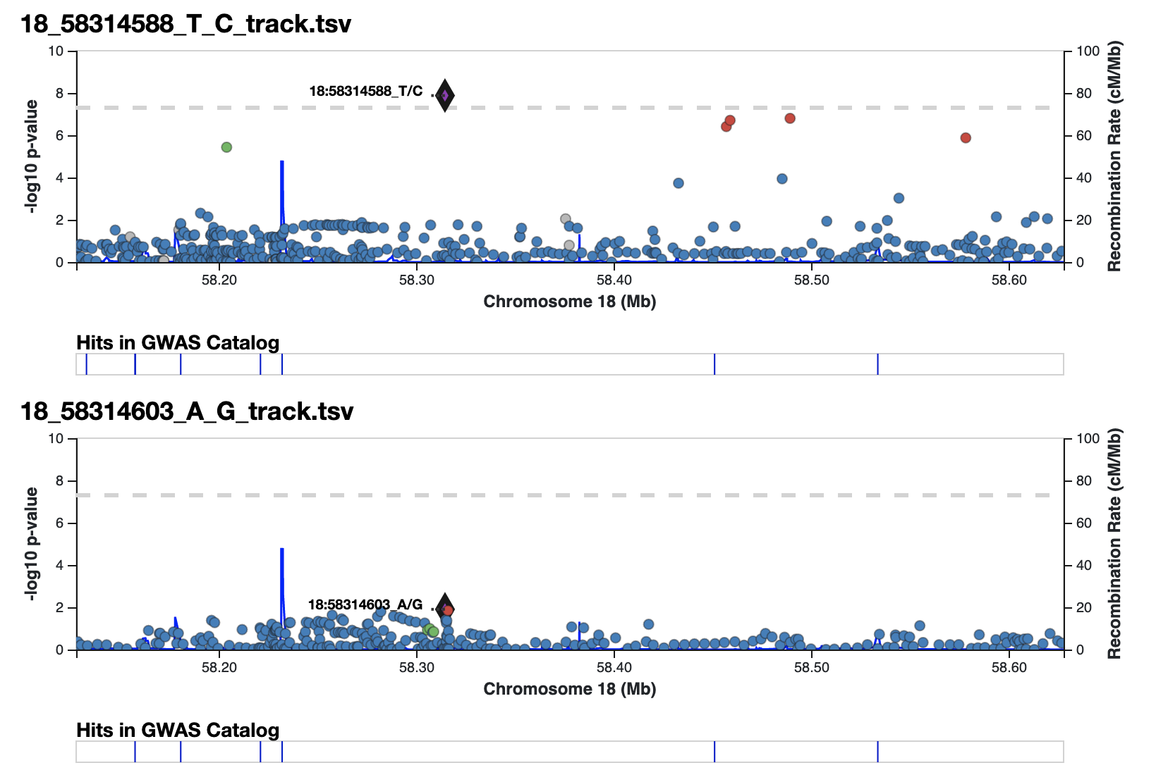

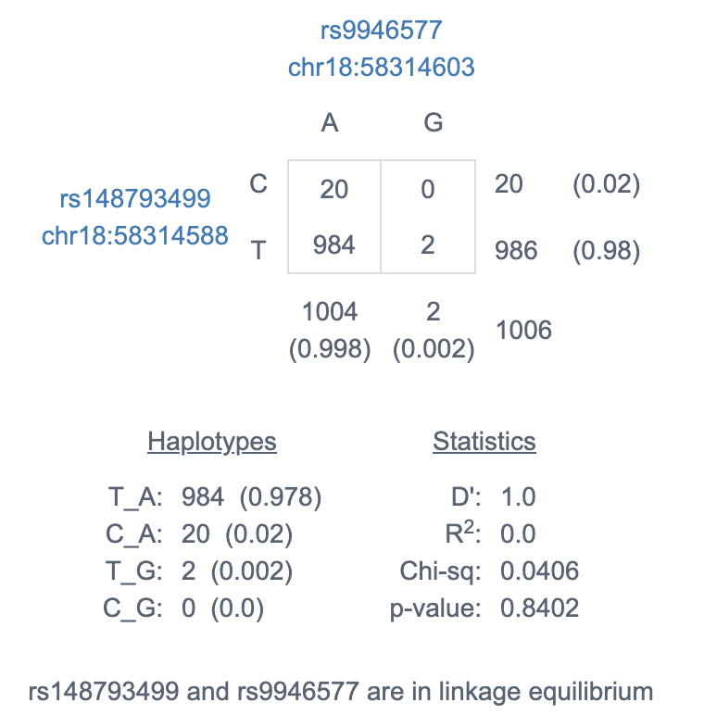

**C. Rs2268616 (14:75419444; MAF = 0.018)**

* Joint associations for each analysis (2 are genome-wide significant), so we think this is mostly finding a main effect of the genetic variant.
* Odds ratio estimate ~1.6 from logistic regression on B2 case status (OR ~ 1.23 for sex interaction (non-significant))
* Found in an intron of PGF (placental growth factor)
* In T2D knowledge portal shows associations with (+) Height (p=0.0002) (+) CAD(p=0.002) (-) HOMA B (p=0.009) (+) PC3 diet (p=0.03) (-) WHI (p=0.027)

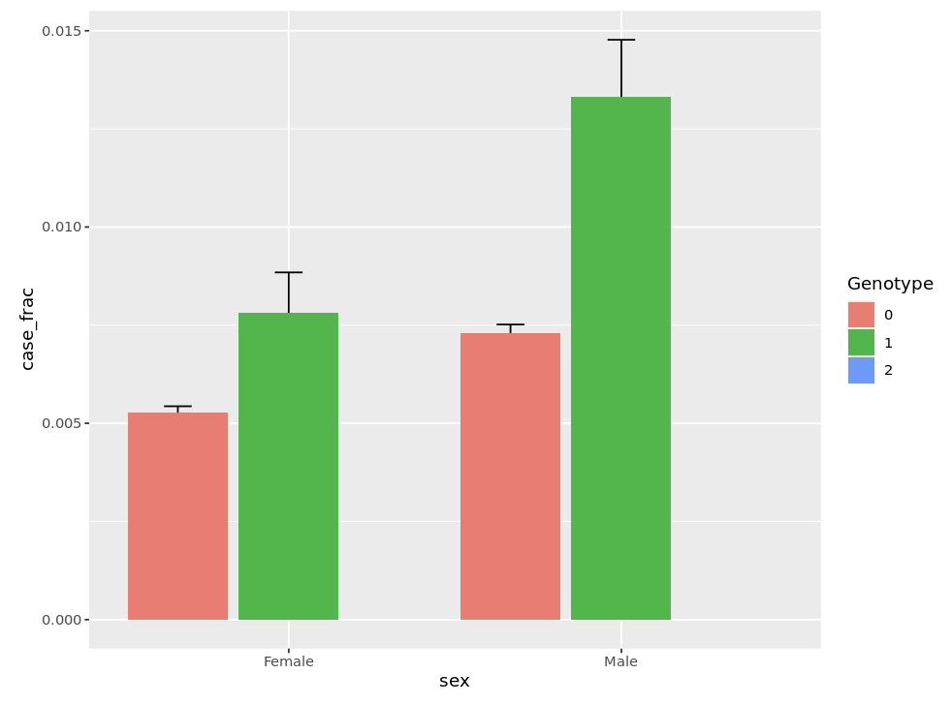

* **No genotype 2 (can’t fully observe clear association/additive effect, can only observe heterozygous individuals that have worse covid)**

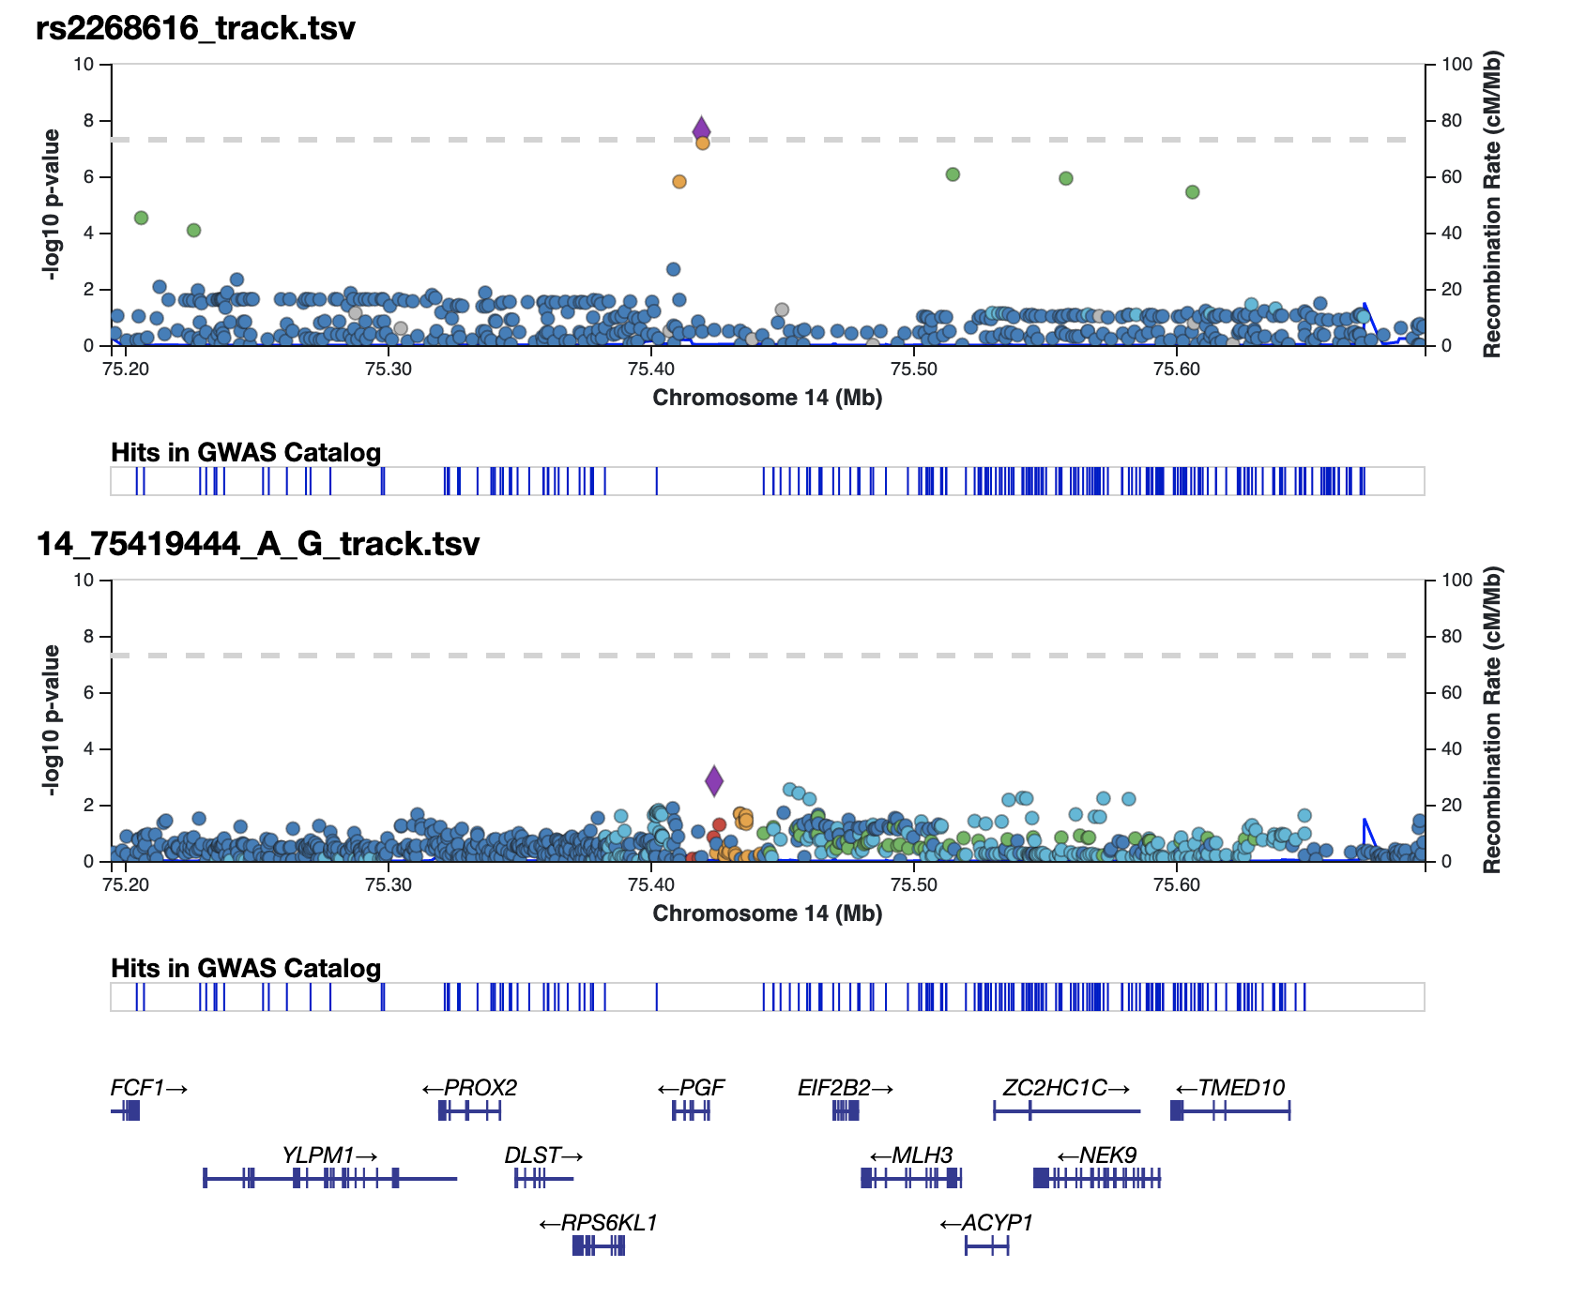

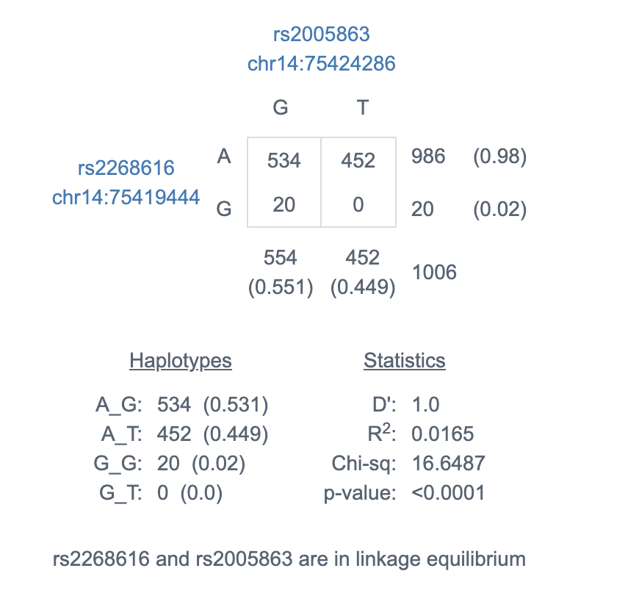

**D. 2:218260234_AC_A (2:218260230, MAF = 0.025)**

* Joint associations for sex
* Odds ratio estimate ~1.32 from logistic regression on B2 case status (OR ~ 1.74 for cardiometabolic interactions (p value=1.24-03))
* Intronic variant with associations nearby DIRC3 gene
* eQTL relationships from GTEx in skin (sun exposed)
* Trait associations from GWAS include body height, breast and thyroid carcinoma, lean body mass, bone density
* **In the T2D KP shows associations with (+) T2D (p=0.105), (+) Fasting glucose (p=0.091) (+) Fasting insulin (p=0.11).**

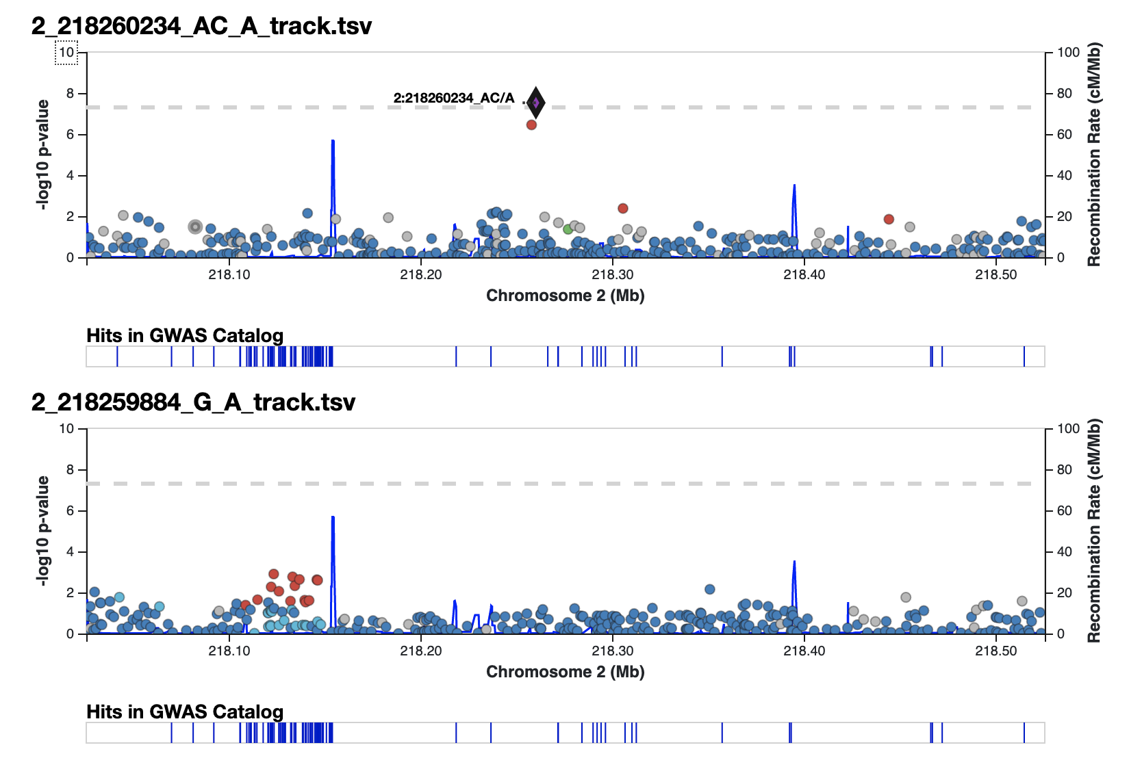

* **Homozygous genotype stronger effect when stratified? Female homozygous have higher prevalence of cases. Male homozygous individuals doesn’t have higher prevalnce of cases.**
* 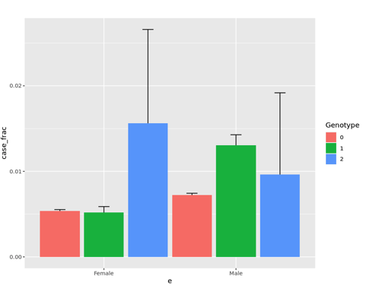

Results v0 april 8th

Table 2A: Sex interaction

|  |  |  |  |  |  |  |  |  |
| --- | --- | --- | --- | --- | --- | --- | --- | --- |
| SNP | location | Alleles (A/T) | Effect allele/ frequency | Combined OR (SE) | Male OR (SE) | Female OR (SE) | Joint P-value | Interaction P-value |
| rs11232355 | 11:80540380 | A/G | G / 0.069 | 0.56 (0.21) | 0.72 (0.16) | 1.21 (0.14) | 9.92211e-07 | 4.54264e-07 |
| rs12461506 | 19:30878810 | G/C | C / 0.64 | 1.49 (0.11) | 1.18 (0.07) | 0.79 (0.08) | 5.89398e-06 | 9.24304e-07 |
| 2:218260234_AC_A | 2:218260234_AC_A | AC/C | A / 0.025 | 1.21 (0.28) | 1.77 (0.18) | 1.46 (0.22) | 2.98606e-08 | 1.27602e-04 |
| rs55926550 | 4:68007466 | G/C | G /0.012 | 0.33 (0.46) | 0.68 (0.38) | 2.04 (0.26) | 4.26531e-07 | 2.29631e-03 |
| rs117993077 | 6:93824151 | G/T | T / 0.011 | 1.43 (0.45) | 1.64 (0.26) | 1.16 (0.37) | 2.29912e-07 | 8.86099e-06 |
| rs11232355 | 11:80540380 | A/G | G / 0.69 | 0.56 (0.21) | 0.72 (0.16) | 1.27 (0.14) | 9.92211e-07 | 4.54264e-07 |
| rs2268616 | 14:75419444 | A/G | G / 0.017 | 0.94 (0.32) | 1.62 (0.21) | 1.71 (0.23) | 2.67280e-08 | 1.39689e-01 |
| rs117234438 | 15:52349607 | A/G | G / 0.01 | 2.60 (0.59) | 1.61 (0.28) | 0.61 (0.52) | 5.01447e-07 | 9.26500e-04 |
| rs13234589 | 7:93967861 | G/T | T / 0.15 | 1.53 (0.16) | 1.18 (0.09) | 0.77 (0.12) | 1.28349e-05 | 2.19333e-06 |
| rs17032616 | 3:156233 | C/T | T / 0.18 | 0.75 (0.13) | 0.96 (0.09) | 1.27 (0.09) | 6.00522e-06 | 2.30334e-06 |
| rs78738346 | 3:60757155 | G/A | A / 0.017 | 2.30 (0.47) | 1.35 (0.24) | 0.59 (0.40) | 1.24654e-05 | 2.45470e-06 |
| rs182113773 | 7:20239837 | C/A | A/ (0.01) | 1.10 (0.37) | 1.73 (0.23) | 1.57 (0.29) | 1.96482e-07 | 8.66041e-01 |
| rs796925608 | 13:68788267 | A/AC.. | AC.. / 0.89 | 0.65 (0.20) | 0.64 (0.12) | 0.98 (0.16) | 7.06026e-07 | 8.41366e-01 |
| rs112561874 | 1:185427460 | G/A | A / 0.015 | 1.07 (0.43) | 1.21 (0.27) | 1.12 (0.33) | 3.53835e-05 | 8.24042e-07 |
| rs11232355 | 11:80540380 | A/G | G / 0.069 | 0.56 ( (0.21) | 0.72 (0.16) | 1.27 (0.14) | 9.92211e-07 | 4.54264e-07 |
| rs17066139 | 3:62113696 | C/T | T / 0.11 | 1.27 (0.15) | 1.44 (0.09) | 1.12 (0.12) | 1.17036e-06 | 1.37132e-02 |
| rs114103616 | 21:16998740 | A/T | T / 0.02 | 0.52 (0.32) | 0.98 (0.24) | 1.84 (0.21) | 1.53455e-06 | 1.41510e-02 |
| rs182465934 | 1:22335633 | C/A | A / (0.02) | 3.00 (0.38) | 1.76 (0.18) | 0.59 (0.33) | 1.88424e-06 | 4.15961e-05 |
| rs758053125 | 20:6586718 | C/T | T / (0.040) | 0.91 (0.30) | 1.08 (0.19) | 1.18 (0.22) | 1.99638e-06 | 8.37289e-06 |
| rs114807731 | 3:60122415 | G/A | A (0.022) | 1.81 (0.34) | 1.63 (0.18) | 0.90 (0.29) | 2.10734e-06 | 2.98353e-05 |

Table 2B: Cardiometabolic interaction

|  |  |  |  |  |  |  |  |  |  |  |  |  |
| --- | --- | --- | --- | --- | --- | --- | --- | --- | --- | --- | --- | --- |
| SNP | location | Alleles (A/T) | Effect allele frequency | “T2D in all effect” OR adjusting for covariates (SE) | BMI in all  effect” OR adjusting for covariates (SE) | Marginal P-value | T2D OR (SE) | Obesity OR (SE) | Joint P-value | Interaction P-value | UK Biobank HGI OR (SE) | UK Biobank HGI P-value |
| rs148793499 | 18:58314588 | TC | 0.01 | 1.01 (0.77) | 1.06 (0.03) | 5.76E-05 | 1.28 (0.72) | 1.03 (0.33) | 1.32E-08 | 8.38E-06 |  |  |
| rs2268616 | 14:75419444 | AG | 0.02 | 1.15 (0.49) | 0.99 (0.02) | 3.87E-09 | 1.85 (0.46) | 1.57 (0.28) | 3.87E-08 | 2.64E-01 |  |  |
| rs11115199 | 12:82510665 | GT | 0.02 | 2.69 (0.44) | 0.95 (0.04) | 4.09E-01 | 2.10 (0.39) | 0.61 (0.41) | 4.85E-08 | 1.37E-08 |  |  |
| rs6035512 | 20:19990781 | CA | 0.02 | 0.82 (0.54) | 1.03 (0.02) | 2.88E-05 | 1.07 (0.52) | 1.59 (0.24) | 8.89E-08 | 1.14E-04 |  |  |
| rs141850011 | 13:61925813 | TC | 0.01 | 6.53 (0.76) | 0.99 (0.07) | 2.25E-01 | 1.72 (0.54) | 0.45 (0.67) | 2.72E-07 | 1.20E-07 |  |  |
| rs28864791 | 13:91502951 | TC | 0.31 | 1.52 (0.17) | 1.01 (.01) | 2.36E-04 | 1.30 (0.16) | 0.96 (0.10) | 2.79E-07 | 5.06E-05 |  |  |
| rs2727176 | 15:100570438 | AG | 0.01 | 2.85 (0.59) | 0.98 (0.05) | 1.78E-01 | 2.55 (0.51) | 1.03 (0.44) | 2.84E-07 | 1.49E-07 |  |  |
| rs144282550 | 4:74917179 | AG | 0.01 | 2.07 (0.52) | 1.00 (0.03) | 3.17E-06 | 3.03 (0.47) | 1.73 (0.34) | 2.92E-07 | 3.20E-03 |  |  |
| rs180972330 | 21:40008094 | AG | 0.01 | 5.19 (0.65) | 1.04 (0.04) | 0.743295 | 2.76 (0.52) | 1.22 (0.43) | 1.51E-06 | 3.54E-07 |  |  |
| rs113083888 | 15:91197671 | CT | 0.05 | 0.63 (0.48) | 1.06 (0.01) | 0.329152 | 0.63 (0.46) | 1.24 (0.19) | 1.03E-06 | 3.65E-07 |  |  |
| rs79091774 | 3:45906878 | AC | 0.03 | 4.21 (0.40) | 1.06 (0.02) | 0.115772 | 2.12 (0.33) | 0.89 (0.28) | 6.62E-07 | 4.94E-07 |  |  |
| rs12649655 | 4:32526020 | CA | 0.23 | 1.64 (0.18) | 1.00(0.011) | 0.122032 | 1.49 (0.17) | 0.92(0.11) | 1.04E-06 | 7.54E-07 |  |  |
| rs28436826 | 4:32524424 | GA | 0.24 | 1.66 (0.18) | 1.00 (0.00) | 0.0746219 | 1.51 (0.17) | 0.92 (0.11) | 7.68E-07 | 8.19E-07 |  |  |
| rs74804867 | 2:122057650 | AT | 0.02 | 4.1 (0.54) | 1.06 (0.03) | 0.329798 | 1.84 (0.44) | 1.04 (0.33) | 2.52E-06 | 9.18E-07 |  |  |

Table 2C: Multiple Deprivation Index interaction

|  |  |  |  |  |  |  |  |  |  |
| --- | --- | --- | --- | --- | --- | --- | --- | --- | --- |
| SNP | location | Alleles (A/T) | Effect allele frequency | MDI effect” OR adjusting for covariates (SE) | Marginal P-value | Joint P-value | Interaction P-value | UK Biobank HGI OR (SE) | UK Biobank HGI P-value |
| rs73164732 | 7:144481768 | G /A | A / (0.01) | 1.02 (0.01) | 1.15E-01 | 5.91E-07 | 3.07E-07 |  |  |
| rs76612061 | 15:49972935 | G/A | A / (0.026) | 1.01 (0.0) | 2.37E-01 | 2.17E-07 | 6.25E-08 |  |  |
| rs148817892 | 16:5934373 | C/G | G / (0.01) | 1.03 (0.01) | 3.27E-01 | 2.52E-06 | 6.28E-07 |  |  |
| rs1646599 | 18:55236161 | G/A | A / (0.01) | 0.09(0.00) | 0.070452 | 6.85E-07 | 5.40E-07 |  |  |
| rs6966810 | 7:20141514 | G/A | A / (0.92) | 0.09 (0.00) | 7.40E-07 | 1.64E-07 | 9.46E-03 |  |  |
| rs72752741 | 9:89168171 | C/T | T/ (.01) | 1.00 (0.00) | 3.56E-05 | 7.01E-07 | 7.98E-04 |  |  |
| rs2268616 | 14:75419444 | A/G | G / (0.01) | 0.09 (0.01) | 1.31E-07 | 3.40E-07 | 1.65E-01 |  |  |
| rs147319526 | 1:231731679 | A/G | G / (0.01) | 1.04 (0.01) | 9.82E-01 | 4.16E-07 | 5.93E-08 |  |  |
| rs147349057 | 6:1059829 | T//TA | TA / (0.015) | 1.03 (0.01) | 3.18E-02 | 1.25E-06 | 2.01E-06 |  |  |
| rs139020188 | 4:35620323 | A/T | T / 0.01) | 1.03 (0.01) | 1.94E-01 | 1.68E-06 | 6.03E-07 |  |  |